# Open Contracting Digital Procurement System

Concept paper

# *Executive summary*

This concept paper summarises a vision for digital transformation of public procurement developed by the EBRD UNCITRAL Public Procurement Initiative, a joint technical cooperation programme of the European Bank for Reconstruction and Development (the EBRD) and United Nations Commission on International Trade Law (UNCITRAL). The paper details the main characteristics of the innovative approach to digitalisation of public procurement function in the government, in line with Open Government principles and building on Open Contracting Data Standard.

Key considerations for implementation of the new digital procurement model are explained from **regulatory, business and technology perspectives** and aim to facilitate a governance model for public procurement function that is delivering:

1. public procurement policy that is user and performance driven;
2. regulatory frameworks that building on recognised international legal standards for public procurement but are engineered for stakeholder feedback & open to collaboration with business community, including small and mid-size enterprises;
3. innovative digital government solutions that are creating online marketplaces for public and private sector alike.

Policy standards are deriving from the Agreement on Government Procurement of the World Trade Organisation, revised in 2012 (the WTO GPA) and legal framework is building on regulatory concepts of the 2011 UNCITRAL Model Law on Public Procurement that reflects latest global best practice for public procurement legislation.

The approach to digitalisation of public procurement is building upon **six main key pillars** that aim to ensure the sustainability of the eProcurement reforms and prioritizes a model that is ensuring a transparent and efficient digitalisation of public procurement function in the government:

1. **End-to-end electronic public procurement:** The eProcurement scheme shall cover the entire public procurement process, from planning to invoicing and payments under public contracts, to increase the transparency and efficiency of procurement;
2. **Sustainable digital government service:** TheeProcurement scheme is fully funded from suppliers’ fees for digital procurement services. No initial funding from state budget and no later exposure of state budget is envisaged, and no fees are charged to public sector users (**Low Cost of Ownership Model**);
3. **Multi-platform networking model**: The eProcurement scheme combines e-government services operated or managed by the government with services of commercial electronic platform operators, in order to create a collaborative delivery scheme that optimises digital service quality and accessibility to end-users among public sector procuring entities and private sector suppliers, service providers and contractors. The eProcurement scheme is open to new commercial platform operators, to encourage innovation by new entrants and keep high quality of service for end-users;
4. **Open source, Open data, Open Contracting Data Standard**: To allow the government to prevent the lock-in effect, only open source applications are used in the system, strengthened for higher transparency and accountability by incorporating the Open Contracting Data Standard
5. **High level interoperability**: eProcurement applications are designed for interoperability with existing and future e-government and e-commerce services;
6. **Cost-and-time efficient implementation**: The eProcurement scheme seeks cost and time efficiencies through a) high-level standardisation of procurement process; b) modular design of electronic workflows, c) the re-use of existing OCDS-based tools and services to offer data analytics and market intelligence functionalities drawing on data from fully digital pubic procurement processes.

The digital procurement model prototyped by the EBRD-UNCITRAL Initiative technical cooperation projects uses an open source and open data distributed architecture for multi-platform networking, similar to blockchain but without a blockchain price tag. Instead of blockchain technology, it uses open data in the format of the open contracting data standard (OCDS) to guarantee data standardisation and ensure user trust in accuracy of data exchange. The digital procurement systems built on this model form a collaborative online network between government-owned and commercial electronic systems. Each digital procurement system consists of a government-owned open-source central database unit, a web portal and several Networking Electronic Procurement Platforms (NEPPs).

Digital procurement service is provided to end-users – procuring entities and suppliers - by a network of e-government services collaborating with commercial platforms. The networking central unit serves as an interoperable online OCDS data exchange and a transaction repository for linked networking commercial electronic platforms (that can be open-source or proprietary), which provide digital procurement services to both buyers and suppliers. Data collected by any NEPP is displayed in real time on an open, accessible, searchable, government-run and open-source web portal. Therefore, the web portal creates a single point of access to all procurement information, including online electronic bidding, because it is automatically synchronised in real time between the government central database unit, the web portal, the NEPPS and, if available, other eGovernment services and digital registers.

Gearing public procurement laws and regulation towards Open Government concepts means emphasising in the regulatory framework transparency safeguards, high levels of integrity and accountability of procuring entities and genuine dialogue with civil society and the business community about public procurement performance and outcomes.

Application of Open Government principles to digital government tools for public procurement means using open-source technologies, open data standards – Open Data for Government Standards (ODGS), Open Contracting Data Standard (OCDS) – and real-time online communication and data exchange. When implemented together, eProcurement tools make it possible for governments to conduct public procurement in a digital and transparent manner, secured by real-time publishing of open data based on OCDS for all public procurement transactions. Reliable and complete information about procurement and public contracts is easily accessible online for all stakeholders – public buyers, suppliers, contractors and also civil society – which is expected to generate trust in government and encourage participation, improving the accountability of procuring entities, enabling the management of the data-driven public procurement process and creating favourable market conditions for competitiveness.

# Policy and regulatory considerations

The procurement process is not an end in itself. Instead, it serves the delivery of public services and should be designed to drive fiscal performance in government, which should result in a high-quality public service for citizens. Regulatory reforms should strive to make public procurement legal frameworks compliant with international policy standards, as well as optimised for the digital economy. Public procurement policy should be clear and accessible, promoting sound governance and competition and taking into account the Sustainable Development Goals.

Public procurement regulation should aim to secure the transparency, accountability and integrity of procurement decisions and maximise the participation of the business community in public tenders, since the level of competition is a recognised driver of value for money in public spending. In other words, a legal framework should be built, based on recognised international standards for public procurement policy but also aimed at obtaining stakeholder feedback and open to collaboration with the business community in order to achieve a public procurement policy that is user and performance driven.

*‘Principle-based’ and ‘technology neutral’ public procurement laws*

Technological progress brings enormous benefits but, at the same time, it is a challenge for legislators, since markets and policies are driven by technology and, therefore, are often subject to change. This challenge was recognised by the 2011 UNCITRAL Model Law on Public Procurement (the “ UNCITRAL Model Law”) and the idea of a “principle-based”, practice-oriented and “technology neutral” public procurement law was brought forward. To be responsive to a changing market and to an evolving technology, primary public procurement laws should prescribe principles to be followed and introduce the key economic concepts of public procurement and general rules for procurement procedures. In this respect, transparency safeguards, value for money through fair competition and fiscal efficiency of procurement for governments are key procurement principles promoted by the UNCITRAL Model Law. At the same time, primary laws should avoid excessively prescribing formats of procurement proceedings – technical detail prone to becoming outdated can quickly be introduced in the secondary legislation on public procurement. Secondary legislation with technical requirements for procurement procedures can be revised more easily, and it enables national legislators and policymakers to match technological progress or market developments and not jeopardise the efficiency of procurement by a lengthy process of amending primary laws.

*‘Regulatory tool-box’ for governments*

The UNCITRAL Model Law provides a description of procurement best practice from around the world in a standardised manner and describes various procurement methods and techniques, as may be needed by governments for different types and values of public procurement contracts. The UNCITRAL Model Law details best practices and methodologies for the execution of each stage of the public procurement process (advertising, solicitation, evaluation, award and contract implementation), and it also explains how procedural steps are combined into a sequence to create different procurement methods suitable for various types of procurement.

The standardisation and clarity of procedural steps, as well as the specification of rules for their combination into procurement methods, facilitate flexibility of procurement regulation while maintaining certainty for procuring entities and predictably of procurement process for participating suppliers.

Standardisation and modularity of the UNCITRAL regulatory framework for public procurement allows to select and set-up procedural options that comply with mandatory policy standards such as the WTO GPA.

*Going digital*

‘Principle-based’ and ‘technology neutral’ public procurement laws promoted by the 2011 UNCITRAL Model Law greatly facilitate digitalisation because of their clear transparency rules and standardisation of public procurement process.

Transparency safeguards are described in detail and listed, and therefore can be well expressed in datasets to be published online as open data in the format defined by the Open Contract Data Standard, to secure high transparency of the public procurement process for all stakeholders. Standardised steps of the public procurement process are easy to map for creating digital documents or specific procurement workflows. This modularity of the regulatory approach is very efficient and it facilitates efficient digital solutions. Modern process engine technologies can be used to provide several different electronic procurement procedures, as needed for various types of public contracts, using the standardised procurement steps expressed in the digital workflow as Lego-style building blocks of the electronic procurement process. This way, electronic procurement procedures based on the UNCITRAL Model Law can be developed to be compliant with various procurement policy standards such as the WTO GPA, while deliberately geared towards minimizing corruption and collusion risks and increasing value for money and fiscal efficiency of procurement for governments, as strongly promoted by the 2011 UNCITRAL Model Law on Public Procurement.

There are four key decisions that define a regulatory model for digital procurement:

1. **Regulate public procurement process, not public procurement procedures.** Each segment of the public procurement market needs different public procurement methods, but they all need a sound regulation of the full procurement lifecycle. Typically, most procuring entities in a decentralised public procurement environment will only use basic/default procurement methods (open or restricted procedures), while procurement techniques such as framework agreements will only be used by large organisations or by centralised purchasing bodies;
2. **Introduce mandatory use of electronic procedures for all procuring entities, big and small, at the same time.** Parallel electronic and paper-based procurement or fragmented mixed electronic-paper process is actually counterproductive for both procuring entities and suppliers, and slows down switch to digital procurement;
3. **Design a new and uniform business process model for electronic public procurement for all types of procuring entities**. Standardisation of the public procurement business process and creating a uniform business model for all procuring entities enables successful transfer to electronic workflows and digital documents. Single process does not mean single platform; standardisation and uniform business process allow operation of multi-platform systems and effective public procurement data collection from different workflows serving different procuring entities. This is possible when all platforms on the market follow the standardised processes and data exchange standards within a unified public procurement scheme;
4. **Adjust institutional structures to digital economy (and digital government) environment.** eProcurement necessitates a new governance structure for the government public procurement function and policy enforcement agencies. Some institutional structures might become obsolete and new capacities might be required when previously existing administrative roles are replaced by automation and data-literacy roles are created in the public administration. The new law has to modify and detail the roles and functions of the institutional structure in alignment with digital processes.

# Business decisions

Public procurement systems should foster and solicit feedback to drive process improvements and innovation. Any public procurement stakeholder who might be affected by a procurement decision of the government should be able to provide feedback and participate at the right time. Feedback by buyers and sellers on each other improves their interactions. Feedback from citizens and users of public services helps improve delivery and builds public trust. It takes time and care to build trust, responding and adapting to changing needs and demands. Still, once civil society and business stakeholders are persuaded that public procurement system serves their welfare, incentives change and coalitions for reforms can be built that can overcome vested interests. The objective of an innovative digital government solution for public procurement should be creating online marketplaces that are delivering quality services for public and private sector alike.

There are six key decisions identified which are defining a business model for digital procurement.

* **Single versus Multiple Platforms**

Based on a review of experiences with both single platforms serving an entire country and multi-platform eProcurement systems in various countries, a concept of **open networking model** has been developed, with a multi-platform system exchanging data among networking platforms in real time, using a central unit and a standardised data exchange format. As a result, public procurement information can be accessed from every platform due to the existence of the OCDS Central Unit that synchronises the data across the network.

Procuring entities can choose the platform to use without long-term contractual commitment to one service provider. Similarly, suppliers and contractors can submit their bids or participate in auctions from any platform regardless of the original platform where the tender was originally published.

The open networking model provides a number of benefits which include:

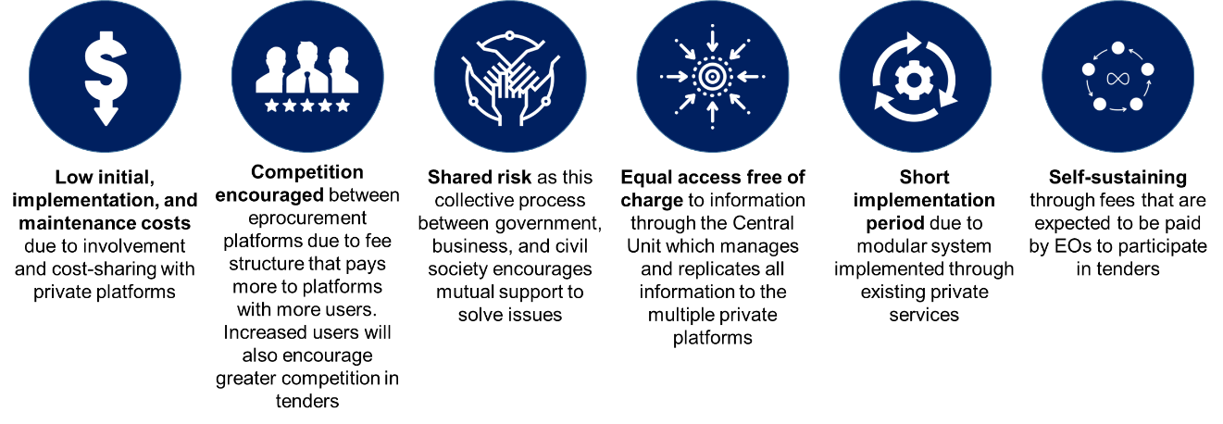

* **End-to-end digital process**

The goal of Digital Transformation of Public Procurement in terms of coverage is **full digital public procurement cycle**, including pre-tendering (ePlanning) and post-tendering (eContract Management) phases. Complete electronic coverage is necessary, not only because it **increases efficiency** but also because it **improves transparency, accountability, and traceability** of public spending. Nevertheless, a complete digital public procurement cycle does not require the development of a single technical solution. The multi-platform networking model allows to design a digital process by which full process coverage is defined by government is terms of eProcurement functionalities, but functionalities are designated to be delivered by e-government services (where available) and/or delegated to the networking commercial platforms, if more affordable.

* **Integration**

The eProcurement system should be integrated with eGovernment services, when available. Integration of eProcurement systems can help achieve several goals towards transparency and efficiency, such as **reduction of corruption and collusion risks** in public procurement, **improved data consistency** and avoidance of duplication, as well as **saving time** for procuring entities and suppliers.

* **Management**

The Digital Transformation of Public Procurement might require adjustments on the institutional structures and their role, as well as on the role and responsibilities of private operators of the electronic procurement platforms.

The main roles identified for the Electronic Public Procurement management ecosystem are the following:

* **Regulatory Authority**: Body responsible for the definition of Public Procurement policies, standards and regulations;
* **Review Body**: Body responsible for reviewing Public Procurement contract-related decisions.
* **Monitoring Unit**: Unit responsible for reviewing and reporting on Public Procurement activity.
* **eProcurement Manager**: IT operator responsible for the maintenance and improvement of the eProcurement system.
* **Central Purchasing Units**: Units responsible for centralised purchasing for several public entities.

The overall approach towards management of the eProcurement systems should **focus on cooperation through the division of functions** between different relevant stakeholders.

* **Acquisition**

The main recommendations related to acquisition of the open networking procurement system is to first develop or deploy the OCDS Central Units that should be government-owned or operated. This ensures that integration with e-government services and digital registers is smooth and that sensitive information is controlled by the government, reducing security risks. To **reduce acquisition costs for eProcurement, available OCDS-based open source solutions** can be used, developed under technical cooperation projects sponsored by international donors (World Bank, ADB, EBRD). The prototypes of the OCDS digital procurement and data analysis tools are available under open-source licences and are deliberately designed for use with minimal IT support and low-intensity maintenance. When required, further development of the tools is intentionally low-cost, low-skills affair. Typically, it can be done by configuration, without additional programming, to keep costs of digital government solution low.

Regarding networking commercial procurement platforms, a standardised business process and technical and functional requirements should be available to connect their platforms to the OCDS Central Unit of the procurement system. It also is important that there is a clear and reliable accreditation process for private e-commerce platform operators before they are able to provide different digital procurement services to procuring entities and suppliers. The accreditation process should include compliance, integration and technical tests that will ensure a ‘single window’, ‘zero paper’ and ‘once only’ digital procurement service.

* **Development (and piloting)**

It is recommended that a **pilot implementation** is planned during development. This will ensure a **smooth transition to full coverage of electronic procedure**s by implementing each newly set up procedure initially as a pilot. Ensuring each new implementation is adaptable to future developments requires the system to be built through **modular solutions**. This means each functionality can be individually developed and is scalable without affecting the rest of the system and still be interconnect with the OCDS Central Unit.

# Technology choices

Existing paper-based procurement procedures should not be taken online, but the entire process should be redesigned as a user-friendly digital service, delivered in collaboration with private sector and benefiting from feedback loop with civil society and supplier organisations. A digital service, with open data and open-source tools operated by the government to secure transparency, accountability and interoperability, and collaborating with commercial operators of the electronic platforms to drive competition and innovation, should become a standard for digital government services.

Standardized OCDS open data and open-source tools help:

• Facilitate interoperability across budget, planning, contracting, payment and project management systems;

• Enable automated data gathering and business analytics;

• Drive analysis and use of the information; and

• Enable the building of interconnected, digital services.

The OCDS data, digital procurement and data analysis tools cover a whole range of aspects of a digital transformation process, including technical planning, problem framing, implementation of OCDS in the system design in case of new and legacy eProcurement systems, use of data, convening and engaging stakeholders, and setting and measuring procurement policy targets.

When drafting the technical and business specifications for an eProcurement system, there are six technological issues which need to be taken into account:

* **End-user technology**

Since eProcurement systems are developed upon web-based services, it shall be ensured that they are adaptable to the most widely used internet tools and software packages. In other words, users should not have to purchase additional software to use eProcurement systems (the system should not require installation of any software for the submission of bids, for example).

* **Interoperability**

The eProcurement system should be fully interoperable with other government services when available and feasible. Interoperability will be ensured with the use of open-source programming and the Open Contracting Data Standard Application Programming Interface (API), which can also be used as a transformation method of information between modules, functionalities and processes.

* **Security**

Security requirements must ensure the protection of information throughout the tendering process. Therefore, all users must be known and correctly identified, and documents and transactions must be kept encrypted and closed until needed.

* **Technology Choice**

Open-source technologies are recommended in order to reduce costs. It is also recommended to have a system based on technologies that have available support for a minimum of 5 years and/or are regularly improved under their respective open-source licences.

* **Infrastructure**

There are two main elements to infrastructure that should be taken into account when designing a new eProcurement system: telecommunications network capabilities and server infrastructure.

Regarding telecommunications capabilities, it is important to ensure sufficient capacity to be able to replicate the procurement data in almost real-time between platforms in order to avoid unfair advantages. In terms of server infrastructure, it is recommended to use cloud services, as they provide several advantages such as cost-efficiency, almost unlimited storage, simple backup and recovery, easy access to information and quick deployment.

* **Architecture**

The digital procurement model uses an open-source and open data interoperable digital procurement architecture for multi-platform networking developed and advocated by the EBRD UNCITRAL Public Procurement Initiative. The digital procurement systems built with this model consist of a government-run central database that serves as an online OCDS data exchange and repository for linked networking commercial electronic procurement platforms, which provide digital procurement services to buyers and suppliers. Central unit works by collecting and recording all the information concerning all stages of the procurement process and the information from the database is displayed on an open, accessible and searchable government-run open-source web portal. This creates a single point of access to all procurement information and electronic bidding that is automatically synchronised in real time between the central unit itself, the government-run web portal, the networked commercial platforms, and (if available) other eGovernment services and registers. Therefore, the system has a networked interoperable digital procurement architecture that relies on the interaction between the single point of access web portal, the data exchange central database unit and a variable number of networking electronic procurement platforms.

The interconnection between the central database and commercial platforms is facilitated by an Application Programming Interface (API) that exchanges data electronically and automatically. Because of the interoperability between the single point of access web portal, the central unit and the networking electronic platforms, a collective authentication, synchronisation and validation of data is achieved in real time for all transactions conducted on the system (which could characterise the system as ‘blockchain-like’). The central unit database is designed in a modular way, so that it can either solely support OCDS data exchange or also operate as a process manager (i.e. ‘smart database’).

The system can be adapted to different market structures for the provision of (de)centralised e-procurement services and to different approaches to the funding or cost-allocation of the system. Multiple central units and multiple networking electronic platforms can be synchronised, which allows for implementation in multi-tier settings, as required by federal countries, autonomy territories or trade agreements.

The open OCDS multi-platform networking digital procurement is designed to cover the entire procurement lifecycle, from planning the procurement to contract management, including electronic online payments and public contract registers. The system is designed to facilitate the automated generation and publication of open procurement data in OCDS format and in real time. This results in a data architecture that ensures that clean and rich open procurement data are available for immediate and broad re-use, without the need for data extraction or further processing. This avoids the negative effects of data manipulation by creating a common source of objective and clean data that is automatically generated and available to all stakeholders– that is, government, businesses and civil society, ensuring a high level of data resilience of the electronic procurement system. Thanks to OCDS open data availability, powerful data-driven analytical tools can be used, for example in order to enable an online complaints mechanism for bidders, online analysis of tender data and data-driven tools for monitoring, auditing and fiscal control of public procurement:

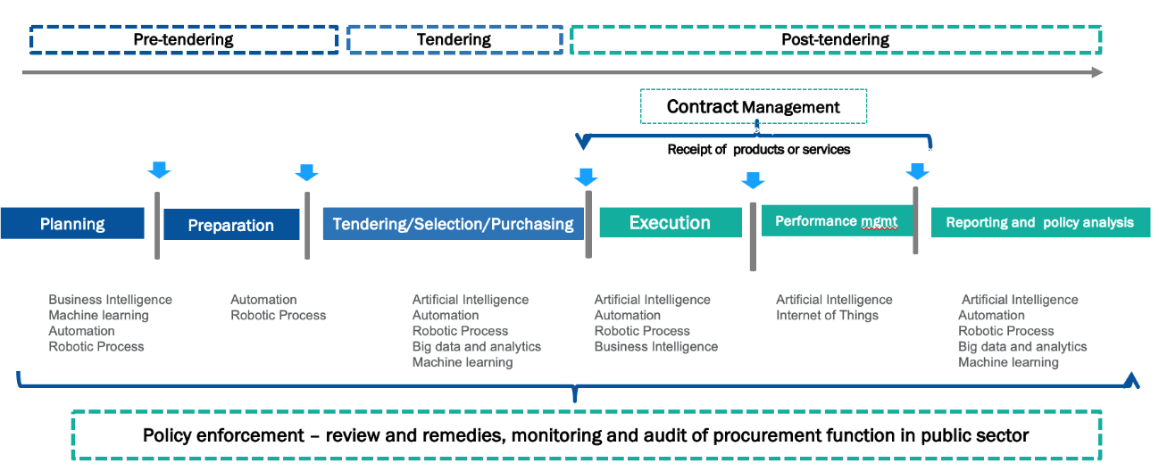

Figure 1 – Digital public procurement cycle

The architecture of the open OCDS multi-platform digital procurement system has been designed in alignment with UNCITRAL Model Law on Public Procurement and it fulfils public procurement policy requirements mandatory under the 2012 text of the WTO’s GPA, delivering a modern digital procurement service covering entire ‘end-to-end’ public procurement life-cycle. It supports all mandatory policy standards of these binding international treaties on public procurement while allowing governments to tailor public procurement policies and digital procurement tools to specifics of local jurisdiction, level of development of domestic market and locally available e-government services and government open data infrastructure.